How to Become an IT Project Manager in the UK

(Updated for 2023)

Hi [@Maheesha Abeyrathne](mailto:maheesha@imperiallearning.co.uk) [Young Indian Businessman Manager Writing Strategy Stock Photo 1986147437 | Shutterstock](https://www.shutterstock.com/image-photo/young-indian-businessman-manager-writing-strategy-1986147437)



*Becoming an IT Project Manager in UK is a really cool journey that you'll find super rewarding. Why being late?* ***Learn and acquire knowledge of Project Management.******2023*** *is the year to* [*start*](https://www.study365.co.uk/) *your voyage through.*

It's a job where you get to do a mix of different things.

* Stuff you know about how things work.
* Being really good at leading people.
* Good communication is important. It means being able to talk to others and understand them. When we communicate well, we can share our thoughts and ideas clearly.
* Knowing project management principles really well.

In today's world of computers and technology, IT project managers are worthwhile. They have a big job of making sure projects in companies go well and are successful. IT project managers are super important in today's digital world. Let me tell you why.

1. Companies always want to use new things to stay ahead of their competitors because **technology** changes really quickly. IT project managers have a really important job. They make sure that new technologies are added to existing systems. They make sure that everything fits together nicely and that there aren't any major issues along the way. organizations are constantly seeking to integrate:

* **New solutions**
* **Tools**
* **Systems to stay competitive.**

1. It's really important for a project to be successful that **resources** like:

* **People,**
* **Money,**
* **Technology**

IT project managers juggle these resources to make project outcomes better. By following limits, they can get the most out of their investment.

1. In the fast-moving online world, **scope creep** is something that happens a lot. IT project managers have an important job. They make sure that projects stay on track and don't get too big or expensive. They do this by setting clear boundaries. Also, make sure that nothing extra gets added that could cause problems.

Understand the IT project Manager Role

An IT Project Manager is a person who plans, does, and watches over technology projects in a company. Their job is to make sure that;

* **projects get done well,**
* **on schedule, and**
* **without spending too much money.**

They also make sure that the projects achieve what they were supposed to.

5 Core Responsibilities of a Project Manager

[@Maheesha Abeyrathne](mailto:maheesha@imperiallearning.co.uk) include info visual 1 idea here

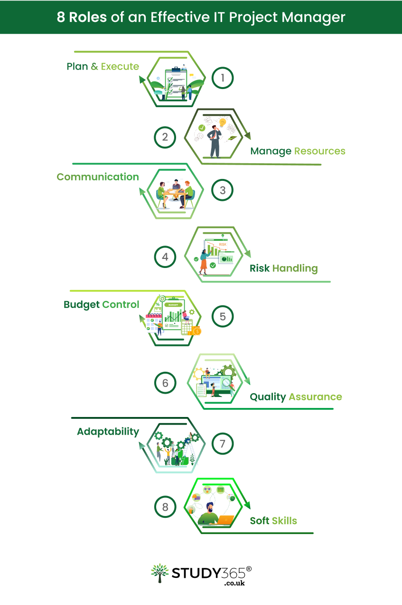

1. **Project Planning:** IT Project Managers make detailed plans for projects. These plans include

* what the project is about,
* what it aims to achieve,
* what needs to be done,
* when it needs to be done by, and
* who will be working on it.

They work together with people involved in the project to figure out what needs to be done and what everyone expects from the project.

1. **Resource Management:** They figure out and assign the stuff they need, like

* people
* tools
* money

to make sure the project goes well.

1. **Scope Management:** They make sure the project stays on track and handle any changes or extra things that might come up. This means looking at requests for changes and how they might affect the project's schedule and money.
2. **Quality Assurance:** They make sure that the things that are made for a project are really good and they make sure that everyone follows the rules. IT Project Managers make sure that the end result is really good and meets or goes beyond what people expect it to be like.
3. **Vendor Management:** IT Project Managers take care of relationships, contracts, and results when outside vendors or contractors are involved. This makes sure that the project goals are met.

Educational Background and Skill Set

Information Technology, Computer Science, and Business Management are some of the most popular degrees that people study. All of these classes are about learning how to use tools, use technology, and run a business. People who study these things learn how to use computers to help companies solve problems and run projects.

But it's not just about knowing how to do things technically. There are also things called "soft skills" that are important. These are important skills, like knowing how to be a good leader, talk to people in a way they can understand, and handle difficult situations.

Gain Relevant Experience

Getting relevant experience is like taking steps towards a successful career in the tech world. There are different jobs that can help you move forward on this journey, like being an:

* IT Analyst,
* Systems Administrator, or
* even a Junior Project Manager.

These roles are important because they help you learn and develop in the field. It's also important to keep improving your skills as technology is always changing. Having a mentor, which is someone who helps and gives you advice, can really make a big difference as well. Hey, just a reminder, every time you learn something new, it gets you one step closer to an awesome future in the cool tech industry!

IT Project Manager Salary Scale for 2023 in 3 levels

1. **Entry-level:** If you're new to being an IT Project Manager, you can expect to make around £35,000 to £45,000 per year.
2. **Mid-career**: As you get more experience and move up in your job, you can earn more money. When IT Project Managers are in the middle of their careers, they typically earn between £46,000 and £65,000 per year.
3. **Senior-level:** For people who are in high-up jobs and have lots of experience, they can earn more money. IT Project Managers, who are at a high level, can make a lot of money, like from £66,000 to £90,000 or even more. The amount they earn depends on how hard and big the projects they work on are.

Obtain Professional Certifications for IT Project Management: Enhance Your Career Prospects

1. One of the coolest certifications for IT Project Managers is called [**PRINCE2.**](https://en.wikipedia.org/wiki/PRINCE2)This certification is extremely significant, especially in the UK. People there really know about it and think it's great. PRINCE2 is really useful for IT projects because it gives you a clear plan to follow and can be adjusted to fit different types of projects, no matter how big or complicated they are. You can use these principles for IT projects to make sure you

* Plan well,
* Manage risks,
* Communicate with everyone involved.

Besides PRINCE2, there are other certifications that can help you stand out in the competitive IT Project Management field.

1. The Project Management Institute (PMI) offers two certifications called:

* **PMP (Project Management Professional) and**
* **CAPM (Certified Associate in Project Management).**

These certifications show that you're really good at managing projects and know a lot about it. They make you more likely to get a good job and show that you're really dedicated to doing a great job.

1. **CompTIA Project+** is a wonderful certification that helps you learn about project management skills. It covers projects:

* Initiation
* Planning
* Execution
* Monitoring
* Closure.

1. [**Information Technology Infrastructure Library:**](https://www.study365.co.uk/course/itil-4-foundation-course/)ITIL is a bunch of rules for managing IT services. Even though it's not just for project management, this certification is really important for IT Project Managers. It helps them make sure that IT services match up with

* what the business needs,
* makes things run smoother,
* and brings more value.

Networking and Industry Participation

Connecting with other professionals in your field can really help you grow as an IT Project Manager. These associations offer a platform to:

* connect with fellow professionals,
* share insights, and
* stay updated on industry trends.

IT Innovation in 2023

In the super-fast world of IT, it's really important for IT Project Managers to keep up with all the new stuff happening. The world of technology is always changing. If you want to do well in your job, it's really important to keep up with these changes.

As of 2023, some notable IT innovations include advancements in:

* **Artificial intelligence (AI) and**
* **Machine learning,**
* **Edge computing,**
* **Quantum computing exploration,**
* **Cybersecurity enhancements, and**
* **Internet of Things (IoT) devices.**

4 Resources for staying currently Updated

1. Online Classes and Courses

Lots of websites have classes and certifications just for IT Project Management. Websites like:

* Study365
* Coursera,
* Udemy, and
* LinkedIn.

They teach you about:

* different ways to manage projects,
* the tools you can use, and
* the best ways to do things.

These courses let you learn at your own speed and get better at different parts of IT project management.

1. Webinars and Virtual Workshops

* **Webinars** are like online classes where you can learn about the newest things happening in IT Project Management. They help you stay up to date with the latest trends and cool ideas. Lots of smart people and groups have online classes called webinars. They talk about different things like how to manage projects quickly and new technologies that are just starting to be used. **One of the main features of the Study365 Educational website is that it provides free webinars. It is a great feature you must gain advantage of.** This is a beneficial factor.
* **Virtual workshops** are like online classes where you can learn and have fun at the same time. You get to talk and learn from really smart people and also make friends with other students.

1. Tech News Platforms

It's really important to check out trustworthy tech news websites. You can stay up to date on what's happening in the industry this way. You'll learn about the

Websites like:

* TechCrunch,
* Wired, and
* CIO Dive

give you cool information about the newest stuff in technology. They talk about things that are important for managing IT projects.

1. Podcasts and Blogs

There are lots of podcasts and blogs all about IT Project Management. These websites and apps have:

* **Conversations,**
* **Interviews, and**
* **Information from smart people,**

so, you can easily stay informed even when you're busy.

Hi [@Maheesha Abeyrathne](mailto:maheesha@imperiallearning.co.uk) include visual 2 infographic idea here

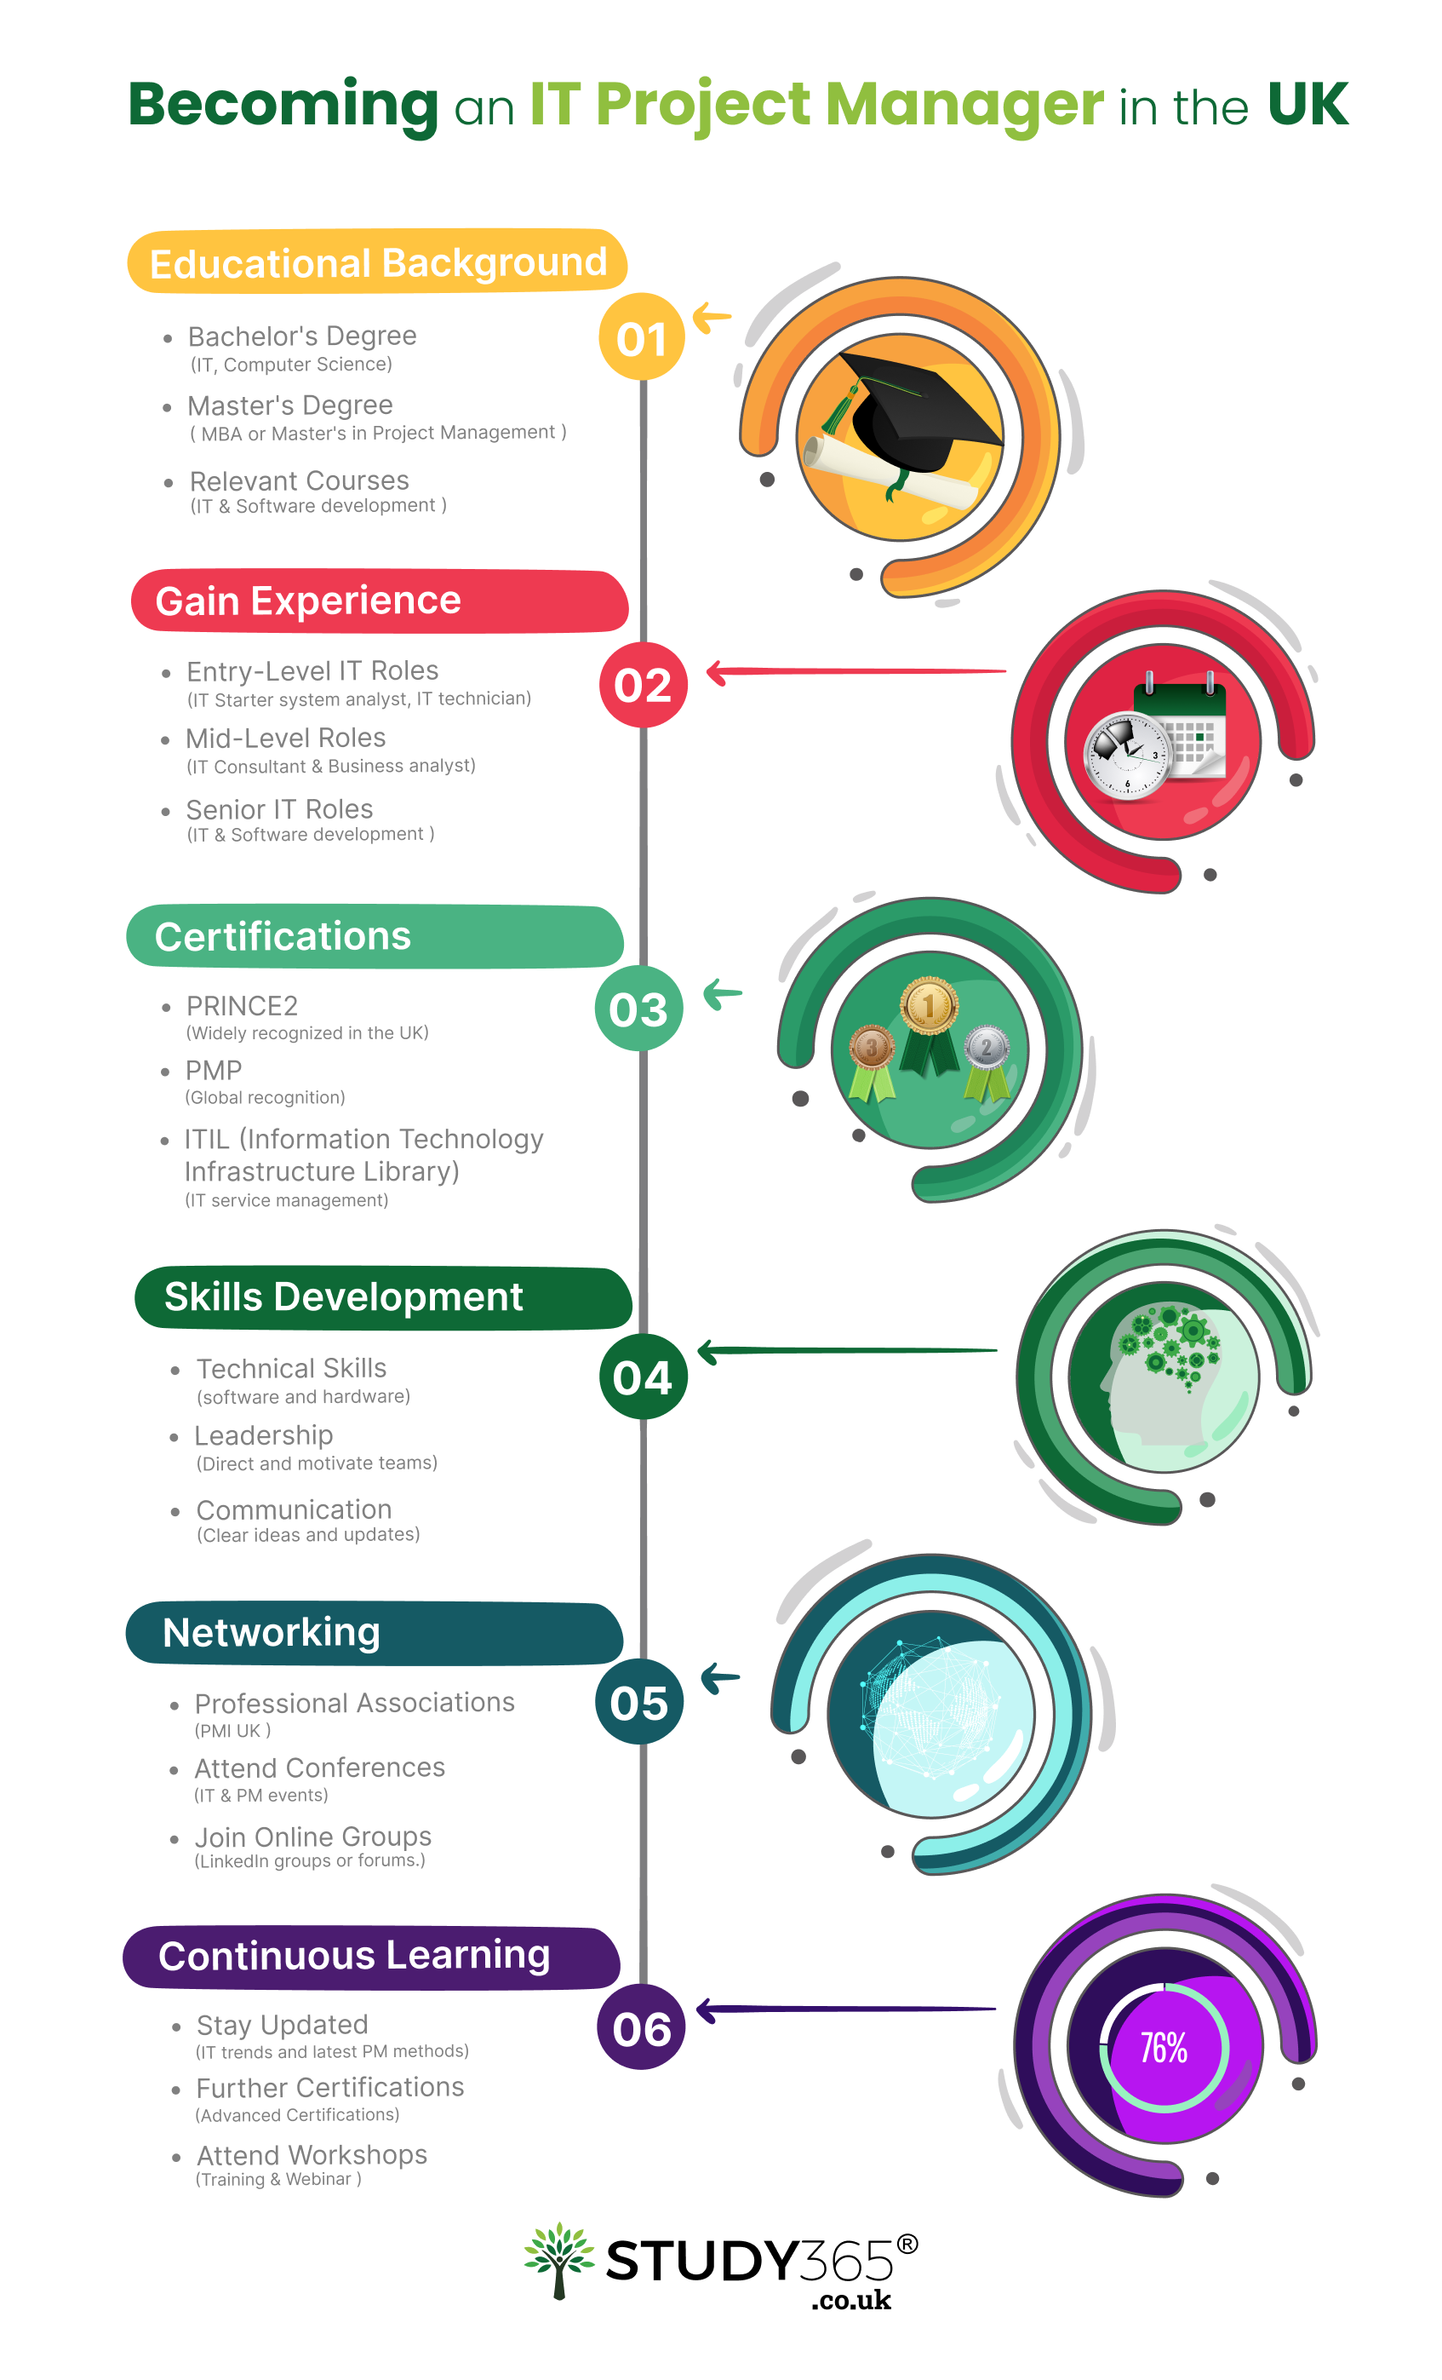

Transition to an IT Project Manager Position

Transitioning into a job as an IT Project Manager means you need to have a plan and a mix of different skills and experiences. *Here's a roadmap to guide your journey:*

1. Develop Your Technical Skills

If you want to be an IT Project Manager, it's really important to know a lot about technology. Improve your technical skills in things that are important for the projects you'll be in charge of, like:

* **Programming languages**
* **Managing databases**
* **Handling networks.**

1. Acquire Project Management Knowledge

To be a good IT Project Manager, it's important to understand the basic principles and processes involved in your job. Learn about different project management methods like:

* **Agile,**
* **Scrum, and**
* **Waterfall.**

So that you are equipped with the knowledge required to succeed in the field.

1. Develop Soft Skills

To be a successful IT Project Manager, it's really important to have:

* **Good communication,**
* **Be a better leader,**
* **Handle conflicts,**
* **Leadership, and**
* **Problem-solving skills.**

These skills will help you do your job well.

1. Highlight Transferable Skills

Make sure to talk about the skills you can use in different jobs that you learned from your past experiences. These skills include:

* **Being organised,**
* **Critical thinking,**
* **Creativity,**
* **Empathy,**
* **managing your time well, and**
* **finding solutions to problems.**

1. Customize Your Resume

Make sure to focus on your technical skills. Include any projects you've worked on. When you're writing your resume:

* emphasising pertinent skills, experiences, and credentials,
* showcase accomplishments and
* prove you are good at handling projects well.

1. Be Adaptable

The world of IT is always changing. Make sure you're open to learning new things, like how to use new gadgets and keeping up with what's happening in your field. It's important to stay updated on the latest trends and changes.

1. Interview preparedness

It's really important to be prepared for an interview.

* **First,** you should do some research on the company you're applying to. Find out what they do and what their values are. This will help you understand if it's a good fit for you.
* **Next,** it's a good idea to practise answering common interview questions. Think about your experiences and how they relate to the job you're applying for. This will help you feel more prepared and confident during the interview.
* **Finally,** make sure to highlight your skills and accomplishments. Think When you answer, be excited and keep it short. Show that you're a good fit for the job with confidence and professionalism.

## Popular IT Project Roles and Top Companies for 2023

1. IT Project Coordinator: An IT Project Coordinator helps project managers by:

* Making schedules
* Keeping track of tasks
* Helping team members talk to each other.

They make sure that:

* Project goals are reached on time
* Resources are used wisely
* All the necessary paperwork is kept organised.

1. IT Project Analyst: An IT Project Analyst:

* Evaluates project data
* Identifies trends
* Provides insights to improve project efficiency.

They analyse data and create reports for informed project management.

1. IT Project Director: An IT Project Director is in charge of all the projects. They:

* Make plans
* Handle budgets
* Lead project managers.

They make sure that everything lines up with the goals of the company and help projects to finish successfully.

1. IT Project Consultant: An IT Project Consultant is someone who helps businesses with their projects. They know a lot about IT and can make sure the projects go well. They:

* look at what the project needs,
* give suggestions, and
* use the best ways to make it happen.

Consultants help connect technology solutions with what businesses need.

Final Words of Summing Up

In the ever-changing world of IT Project Management, being successful means

* having good technical skills,
* thinking ahead, and
* being able to communicate well.

IT Project Managers are really smart people who know a lot about technology and have big ideas. They use their skills to make sure:

* projects stay on track and
* reach their goals,
* even when things are always changing.

Propel Your Journey to Becoming an IT Project Manager in the UK! [**Login**](https://www.glassdoor.com/Explore/top-project-manager-companies-united-kingdom_IO.4,19_IL.30,44_IN2.htm)to discover top Companies in the UK that provide jobs in the field of project management.

Embark on the PRINCE2 Certification course from [**Study365**](https://www.study365.co.uk/)to lay down a robust foundation in project management. Tailored specifically for the IT industry in the UK, this is your ticket to success.

FAQs

1. What is the role of a project manager in IT project management?

An IT project manager plays a pivotal role in:

* planning,
* executing, and
* overseeing technology-related projects.

They are responsible for ensuring that projects are completed:

* successfully,
* on time, and
* within budget,
* while aligning with the project's goals and objectives.

1. What is a successful IT project?

Good IT projects are the ones that:

* Do what the business needs them to do,
* Get finished and taken care of on time,
* Get finished and taken care of without spending too much money, and
* Give the business what it wants and make a good profit.

1. Who is an IT project manager

An IT project manager is someone who is in charge of making sure that a company's IT projects go smoothly. They

* plan,
* do, and
* give out tasks

to make sure that the company's IT goals are met.

1. Is IT project management a good career?

Being a project manager is not a simple and easy job to have. But one of the best things about it is that when you work hard, people notice and give you something nice in return. It's a really good job choice that you'll definitely be happy with. It is a lucrative career path.

## Infographic Content

**Visual 1**

**Title**: “**8 Roles of an Effective IT Project Manager**”

**Introduction:** An IT project manager plays a vital role in orchestrating the successful execution of technology projects.

**Content:**

1. **Plan & Execute**
2. **Manage Resources**
3. **Communication**
4. **Risk Handling**
5. **Budget Control**
6. **Quality Assurance**
7. **Adaptability**
8. **Soft Skills**

**Summary:** An IT project manager's role involves striking a balance between technical expertise and soft skills. This ensures successful project execution and fosters collaborative innovation.

**CTA:** Get Started with [Study365.](https://www.study365.co.uk/)

**Visual 2**

**Title: Becoming an IT Project Manager in the UK**

**Educational Background** **Visual:**

1. **Bachelor's Degree:**

*(IT, Computer Science)*  
  
 2. **Master's Degree :**

*( MBA or Master's in Project Management )*

3. **Relevant Courses:**

*(IT & Software development )*

**Gain Experience:** Visual:** Clock or calendar pages flipping.

1. **Entry-Level IT Roles:**

(IT Starter system analyst, IT technician)

2. **Mid-Level Roles:**

(IT Consultant & Business analyst).

3. **Senior IT Roles:**

(IT Project Manager & Leaders)

**Certifications**\*\*Visual:** Badges or certificates.

1. **PRINCE2:**

(Widely recognized in the UK)

2. **PMP**

(Global recognition)

3. **ITIL (Information Technology Infrastructure Library):**

(IT service management)

**Skills Development:** **Visual:** Brain or toolbox.

1. **Technical Skills:**

(software and hardware)

2. **Leadership:**

(Direct and motivate teams)

3. **Communication:**

(Clear ideas and updates)

**Networking:**\*\*Visual:** Linked hands or network web.

1. **Professional Associations:**

( PMI UK )

2. **Attend Conferences:**

-(IT & PM events)

3. **Join Online Groups:**

( LinkedIn groups or forums.)

**Continuous Learning:** **Visual:** Evolving gear or a progress bar.

1. **Stay Updated:**

(IT trends and latest PM methods).

2. **Further Certifications:**

(Advanced Certifications)

3. **Attend Workshops:**

-(Training & Webinar )